**Kaas Plateau**

The **Kas Plateau Reserved Forest**, also known as the **Kaas Pathar**, is a plateau situated 25 kilometres west from [Satara](https://en.wikipedia.org/wiki/Satara_(city)" \o "Satara (city)) city in [Maharashtra](https://en.wikipedia.org/wiki/Maharashtra), [India](https://en.wikipedia.org/wiki/India). It falls under the [Sahyadri Sub Cluster](https://en.wikipedia.org/wiki/Sahyadri) of the [Western Ghats](https://en.wikipedia.org/wiki/Western_Ghats), and it became a part of a [UNESCO World Natural Heritage Site](https://en.wikipedia.org/wiki/World_Heritage_Site) in 2012.

Kaas plateau is a plateau located near [Satara](https://en.wikipedia.org/wiki/Satara_(city)" \o "Satara (city)). It is situated high hill plateaus and grasslands turns into a 'valley of flowers' during monsoon season, particularly from August to early October. Kaas Plateau has more than 150 or more types of flowers, shrubs and grasses. The orchids bloom here for a period of 3–4 weeks during this season. Kaas plateau is a World Natural Heritage site, part of the Sahyadri Sub-cluster.

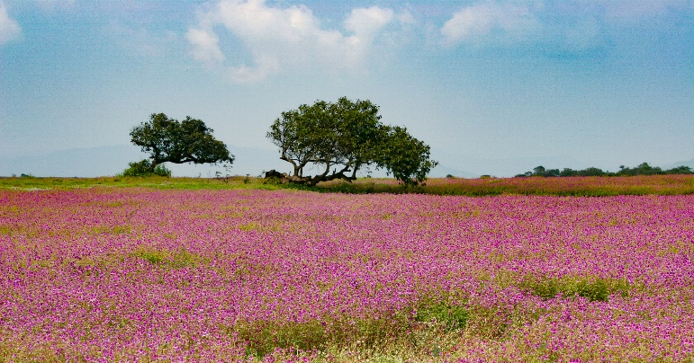

1st photo:

<https://www.google.com/search?q=kaas+plateau&rlz=1C1CHBD_enIN932IN932&sxsrf=AOaemvIaxPi5Llxr8mWn-5U8Enr215Migg:1633019772230&source=lnms&tbm=isch&sa=X&ved=2ahUKEwjUgb3bkKfzAhUYfX0KHTNmA0oQ_AUoAXoECAEQAw&biw=1536&bih=696&dpr=1.25#imgrc=INTm7ErxV47aRM>

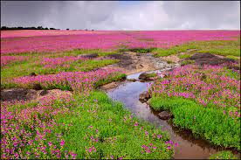

2nd photo:

<https://www.google.com/search?q=kaas+plateau&rlz=1C1CHBD_enIN932IN932&sxsrf=AOaemvIaxPi5Llxr8mWn-5U8Enr215Migg:1633019772230&source=lnms&tbm=isch&sa=X&ved=2ahUKEwjUgb3bkKfzAhUYfX0KHTNmA0oQ_AUoAXoECAEQAw&biw=1536&bih=696&dpr=1.25#imgrc=7u8Px6YnEkhURM&imgdii=tLgPTJHz_snVzM>

Vlog:

<https://youtu.be/Ac0Fb_GchAs>